Title of Lesson | Time Required | Age Range | Resources required
Shoes Clues | 2 hours | 14 - 17 | As many shoes as there are students. Shoes must be of different types, sizes, brands, etc. Every shoe must come with the picture and profile of the owner.

Lesson Objective | Knowledge and Understanding (Global Theme covered) | Global Skills covered | Global Values and Attitudes covered
- develop a sense of empathy by stepping into someone else's shoes  - help understand the meaning of stereotypes  - encourage expressing one’s opinion and understanding another person’s point of view | Identity and diversity | Empathy | Value diversity

Introduction
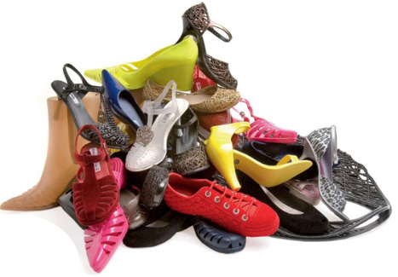
This activity requires detailed preparation and the production of character profiles to deliver successfully.
Clues Task 1: The teacher tells the students different keywords (red/ sky/ summer/ forest/ animal/ game/ piece of clothing/ etc.). The students have to write down the first corresponding word that comes to their mind. After completing the list, the words are compared and contrasted frontally. The teacher can use the following questions: Are the words similar? Why do you think it is so? Has it got anything to do with the stereotypes? What is a stereotype?
Task 2: “Fishing for shoes”- the teacher has tied a long string to every shoe. The shoes are hidden behind a cloth, so that every student “fishes” for a shoe, which will be theirs for the rest of the class. An easier option is to put all the shoes into a bag and ask every student to choose a shoe blindfolded

Main Activity
Give the students some minutes to think about the shoe they have in their hands (who/ what kind of person does it belong to)?
Frontal discussion on the following questions:
- What does the owner of your shows look like? What makes you think so?
- What is their personality like? What makes you think so?
- How old do you think they are? What makes you think so?
- What nationality are they? What makes you think so?
- What do they do for a living? What makes you think so?
- Are they married or single? What makes you think so?
- Do they have any children? What makes you think so?
- Do they live in the country or in town? What makes you think so?
- Do they lead a healthy lifestyle? What makes you think so?
- What do you think their hobbies are? What makes you think so?
- What are their political views? What makes you think so?
- What was their childhood like? Why do you think so?
- What do you like/ do not like about this person?
- Would you have dinner with this person? Why (not)?
- Would you go travelling with this person? Why (not)?
- Would you share a house with this person? Why (not)?
- Would you like to be friends with this person? Why (not)?
During the discussion students take notes about their “person”.
Plenary
Students draw their “person” according to their notes and vision.
Then the teacher provides every student with the picture and profile of the actual owner of the shoe.
Students compare their vision with the reality by creating an exhibition (10 mins).
Finally a discussion is held about if and how stereotypes influenced the choices the students when creating an image of the owner of the shoe.
What were the Outcomes?
The students gained a better understanding of the meaning of stereotypes, the ability to recognise stereotypes and understanding how stereotypes influence us.

