Title of Lesson | Time Required | Age Range | Resources required
More Equal than Different | 1 - 2 hours | 11-16 | News headlines/stories on immigration or story/songs about sense of identity or belonging  Drawing materials

Lesson Objective | Knowledge and Understanding (Global Theme covered) | Global Skills covered | Global Values and Attitudes covered
To explore the fears and feelings behind prejudice and discrimination | Identity and diversity | Critical and creative thinking | Respect for people and human rights  Value diversity

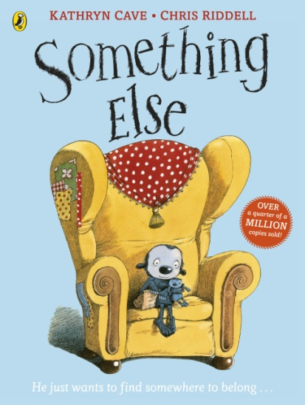
Introduction
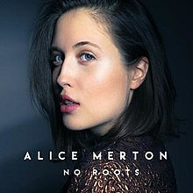
This activity explores the complexity behind identity and belonging. It is useful when stories around migration or incidents of racism are in the news - these can be used as a stimulus for discussion and analysis.
What is the message of this headline/picture/story? Is it inclusive or is it separating people into groups? What is an "in" group and What is an "out group"? Is it important for people to be accepted? What prevents people from feeling that they belong in a place? How do we overcome fear of the new and unknown?

Alternatively, a story such as "Something Else" by Kathryn Cave or the song "No Roots" by Alice Merton can also be used to explore the concept of belonging - with older children it is important to focus on the themes behind the story and identify these to generate discussion and explore different perspectives.

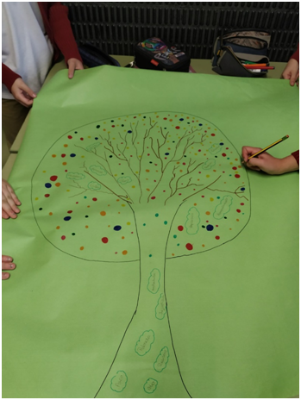
Main Activity
Once students have started to explore the themes and appreciate the complexity of the issues they can begin to mind map their thoughts and ideas.
In small groups students draw a tree with roots, trunk and branches.
In the roots they should write the fears and prejudices that people manifest towards those considered different to themselves.
In the trunk they can write or draw the types of prejudicial and discriminatory behaviour that result in daily life.
In the branches they can write the feelings and possible impacts of these actions on individuals or communities
Above the top of the tree, in the sky or clouds, they will write their wishes for a society where all people are
treated with respect, justice and solidarity. What would a society prioritising human rights look like? Students can write, draw and imagine their hopes and dreams for humanity in the future. Can hatred and discrimination be overcome? How can it be challenged? What needs to change?

Plenary
Students can visit each other’s issues trees, to look for shared ideas or priorities, or borrow a thought which they can take away to add to their own tree.
Some questions for reflection:
Why do majority groups develop protectionist behaviours rather than be more open to outsiders?
How do we react when we face the difference? What do you do?
When do you feel rejected? Who has to act in order to achieve a space of intercultural coexistence?
How can we facilitate positive cultural exchange?
How can we learn to live together harmoniously?

What were the Outcomes?
This activity helped students to explore prejudices, actions and ideals and the relationship between these.
It supported them to unpick underlying assumptions, values and attitudes which influence human behaviour and communication. The students became more aware of their own emotions, thought processes and reactions and how they both influence, and are influenced by others. It enabled them to appreciate complexity in more depth and imagine an alternative future.

