Title of Lesson | Time Required | Age Range | Resources required
Finding Connections | 1 hour | Written for young children but can be adapted to suit any age range | - Large ball of wool  - The World Came to My Place Today story book  - Items mentioned in the story  - List of items required for the activity (download from webpage)  - Large Floor World Map (countries numbered for younger children)

Lesson Objective | Knowledge and Understanding (Global Theme covered) | Global Skills covered | Global Values and Attitudes covered
To explore interconnections between people and places in everyday life | Globalisation and  Interdependence | Empathy  Communication  Cooperation | Sense of identity and self esteem  Valuing diversity

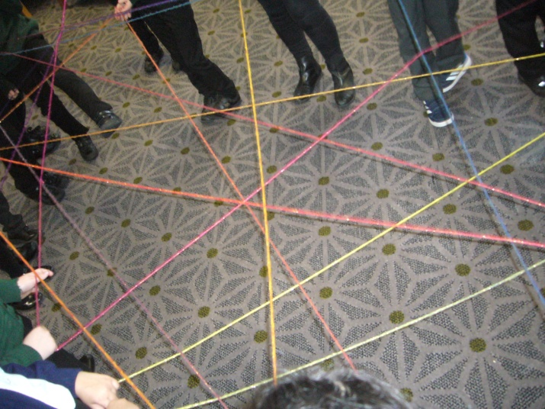
Introduction
Children stand in a circle and a volunteer introduces themselves "My name is......... and I like............." This child holds the end piece of the ball of wool and chooses another child, who indicates they like the same thing (colour, food, game, animal etc), and passes the ball of wool on to them. This child then introduces themselves and a "new" like to the group. The game continues until all the children are included and a web of interactions is visible in the form of a wool web.
Teaching point - There are many ways we are connected together that we cannot see in real life. We all need each other to make the web pattern - if one person drops the wool the web is spoiled and the wool is tangled. We all need each other and rely on other people to look after us and help us.
Undo the web, working backwards from the last child to receive the wool, releasing the children one by one until the ball of wool is complete again.
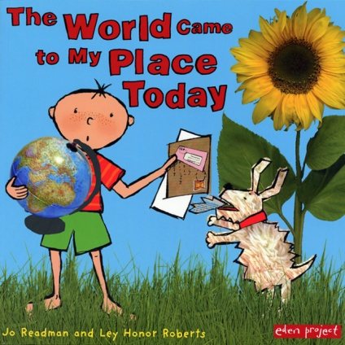
Main Activity
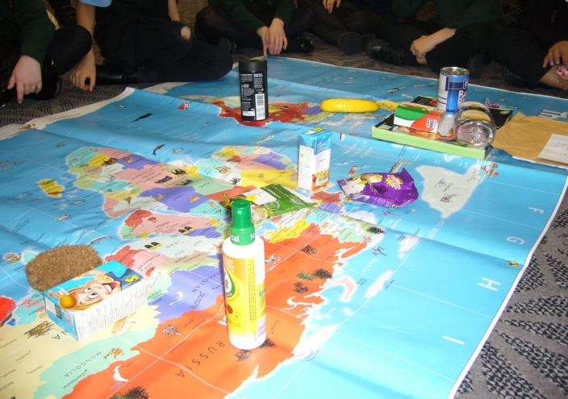
Introduce children to the food and other items in the story The World Came to My Place today. Allow children to randomly pick or select the item they are to hold and look after.
Older children may like to discuss their choices in pairs or suggest possible connections - Is there anything you need before you come to school? Which items help to clean things? Were any of the items once living things? What is the packaging made from? Support the children to make their own connections and justify their choices.
Roll out the floor map and read the story - encouraging the children to find the correct country for each item mentioned in the story and place it on the map.
Numbering the items and positioning the corresponding numbers on the map will support younger children to complete the task.
On completion of the story ask the children "How does the world come to our place everyday?"
Reinforce that foods, clothes, cars, people are moving around the earth all the time. Many things we use and need everyday have ingredients/components from many different places and have involved many people working to get it to our home.

Plenary
The wool web activity can be repeated this time asking a child to share their favourite food eg. chocolate and adding in the different ingredients in order for the food to be made, joining in new children to represent the ingredients, building an awareness of local or global supply chains.

What were the Outcomes?
The children developed a greater understanding of interdependence and how we are all interconnected.
It also worked well with older children who identified key themes from the book and made direct comparisons with their own experiences. It provided opportunity to explore identity and share commonalities with children within the group and then look for broader connections to others around the world. The children retained vivid memories of the web activity and how it illustrates interdependence.

