Title of Lesson | Time Required | Age Range | Resources required
A Sweet World | This could be a whole school activity day or take place as single sessions over a number of weeks. | 6 & under | Story with food as a central theme, such as La Pasticceria Zitti or similar  www.spaziodi.it/magazine/n0506/vdb.asp?tag=FIABA&id=1311

Lesson Objective | Knowledge and Understanding (Global Theme covered) | Global Skills covered | Global Values and Attitudes covered
To understand that foods and stories from different cultures can improve intercultural awareness | Identity and diversity  Globalisation and interdependence | Empathy  Communication | Sense of identity and self esteem  Value diversity
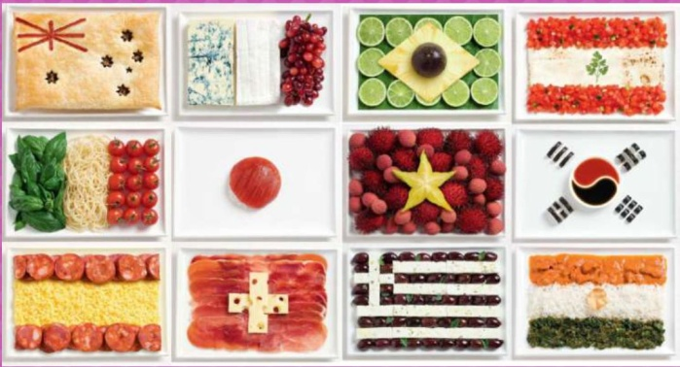
Introduction
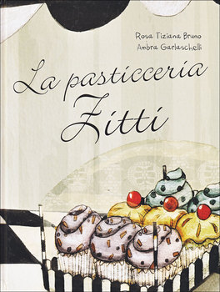
Providing opportunities for meaningful, sustained interaction between parents, children and staff within the school helps to develop trust, understanding which benefits the learning of the child and integration of new communities. Respect for cultural backgrounds, language and experience needs to be embedded in the school ethos through the celebration of commonality and difference wherever possible.
This activity uses food to increase parental engagement, celebrate identity and diversity and promote a sense of belonging and recognition for the whole school community.

Main Activity
The project was introduced using the story La Pasticerria Zitti (Mr Zitti's Cake shop) by Rosa Tiziana Bruno as a stimulus activity. The story explores complex themes while introducing the idea that food can overcome intercultural, language or disability barriers http://www.spaziodi.it/magazine/n0711/vd.asp?id=2625
This story provided opportunities for talk, imaginative play and creative activities within the classroom.

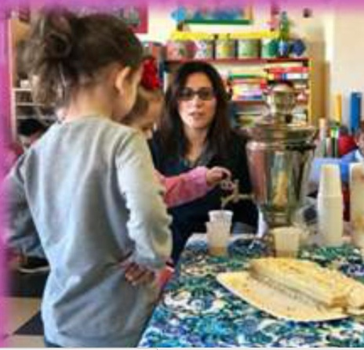
Follow on activities were designed in collaboration with parents. Each family offered a dessert typical of their country for the children to taste, touch and smell. Each parent was also encouraged to tell a story related to the cultural traditions of the country of origin. Photographs were taken showing the journey around the world through the foods and stories to illustrate the learning journey.

Plenary
Opportunities for children to ask questions, share responses and ideas were built in to each session. This helped to extend vocabulary and build confidence in speaking and listening skills. Children learnt to follow instructions and develop social skills through cooperation and communication.
Older children within the school took turns to participate in the activities, recording the family recipes and favourite stories. They designed recipe books written in Italian and English to celebrate the Sweet World activities. This involved them in active learning opportunities as interpreters, mediators, peer mentors and authors throughout the course of the programme.
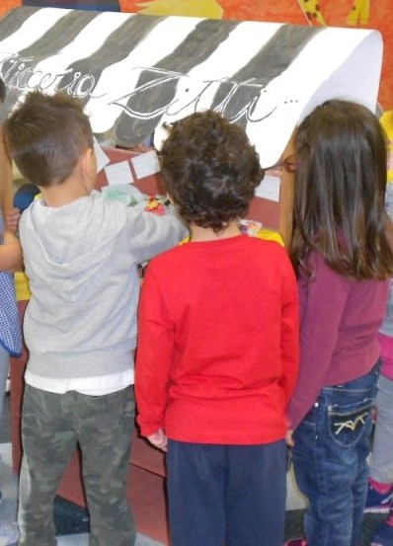
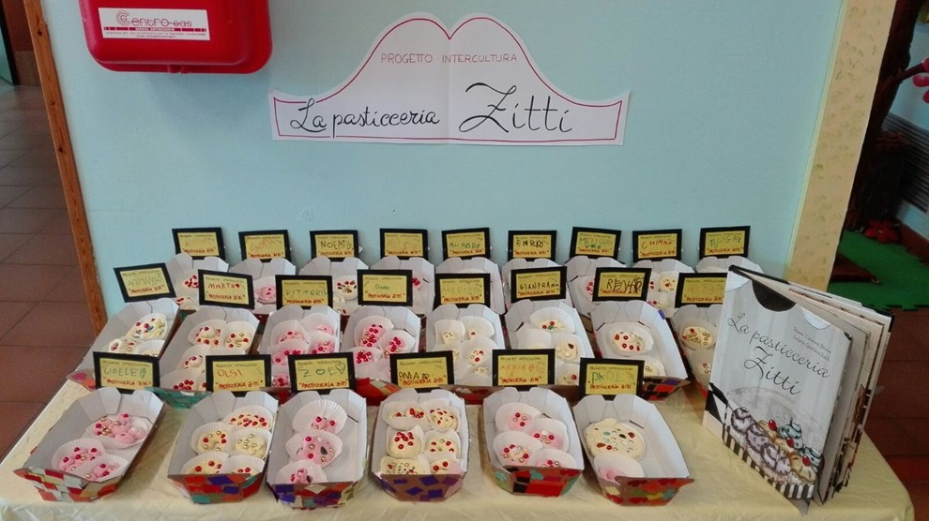

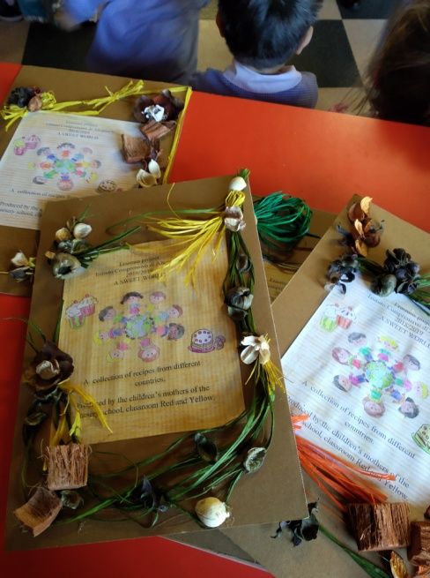
What were the Outcomes?
The younger children responded positively to the parents taking the role of "special teachers" and the programme increased the bond and deepened cultural understanding between the families and the school.
The older children were highly motivated by their active role, having a real audience and purpose for their social interaction, language learning and written work.
The parents experienced that they were crucial partners in the education of their children. Both parents and children felt valued and respected.
All activities were documented with photographs displayed around the school to generate discussion and celebrate diversity within the school community.

