Title of Lesson | Time Required | Age Range | Resources required
New People New Places | 2-3 hours | 7+ | Road map mat/cars  Drawing/writing materials  Visitors  Construction toys

Lesson Objective | Knowledge and Understanding (Global Theme covered) | Global Skills covered | Global Values and Attitudes covered
To understand that people need to move for many reasons and need help to adapt to change | Identity and Diversity | Creativity and critical thinking  Self awareness and reflection  Ability to manage complexity and uncertainty | Respect for people and human rights  Belief that people can bring about change
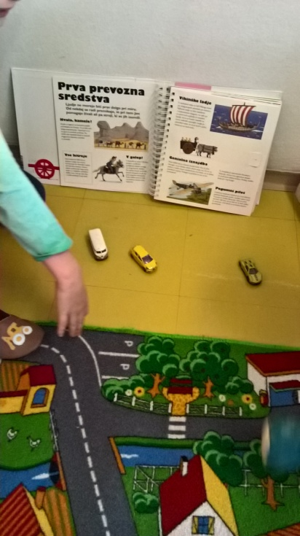
Introduction
This lesson grew out of an after school club where children were playing freely with cars using a floor road map.
The children started to discuss which cars they like best and their attributes "I want the Ferrari, it's the fastest" .
Use road map and toy vehicles as a stimulus for class/paired discussion - Which transport toy is your favourite? What do you like about it? Do you have special memories of a transport toy from when you were younger?
Think, Pair and Share -Tell your partner about a favourite transport toy you have or remember well. Share responses with larger group/class.
Support the children to make a link between imaginative play and everyday life, people, places and travel. Discuss how modes of transport are suited to different uses and distances.
Carry out a simple survey recording how children travel to visit the park, relations, go on holiday, get to school, go shopping - children draw pictures of themselves/transport they use and build up a class picture chart of their results.
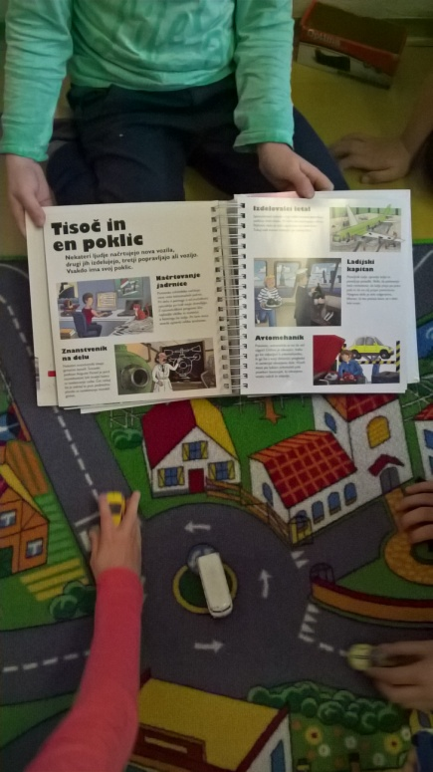
Main Activity
Introduce the idea that people may need to move home for many reasons. Collect in reasons and discuss with the children, drawing on personal experiences that the children are happy to share or make connections with stories/films/famous people they know about that involve moving to a new home.
What might push or pull a family into moving to a new place away from where they live now?
Invite parents or visitors in to school to describe how they have needed to move house or live in a new town or country for work, family reasons, studying etc Help the children to prepare questions to ask them - Were you sad about moving? Did you have to learn new things? Did anybody help you? How did you make new friends?
After the visit - Using construction or drawing materials children create buildings for a town/school where new children/visitors will feel welcomed and help them to describe actions they could take to help them settle in and make friends. Can they work in groups to design a flag and invent a name for their town?
Ensure that the children understand that the values and attitudes of people are a key factor in making a welcoming place.

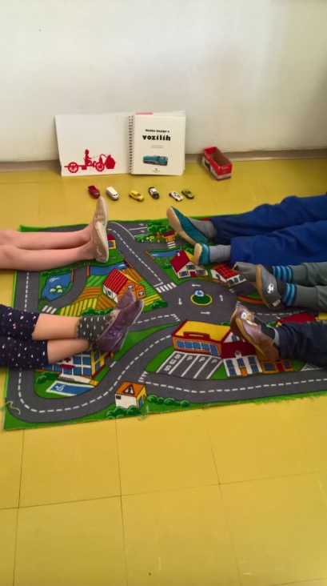
Plenary
Children present their models and flags explaining their ideas to each other and comment on what they like about each others' work.
Display children's models with captions showing children's ideas for making their class/school friendly and welcoming to new comers. The activity could be extended into map making, drawing around the base of the models to create a plan view and creating a key to label buildings or land use if appropriate.
Rehearse/role play welcoming new children into the class in pairs - using friendly body language, sharing equipment, explaining where to go etc to raise awareness of the feelings and needs of others in a follow up drama session.

What were the Outcomes?
The children learnt that people travel and move to new places for many reasons.
They developed an understanding that there are complex choices and decisions to make in life.
Empathy was encouraged through opportunity to engage with the personal stories of class visitors.
The important role people have in creating welcoming, inclusive communities was demonstrated through creative activities.

