Global Skills Progress Tracker – How do you rate your global citizenship skills?

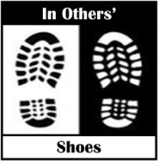
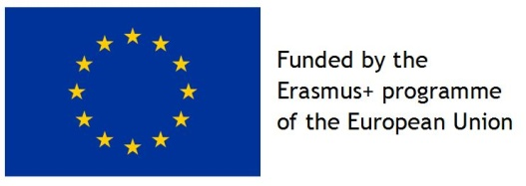
Score yourself to plot your skills progression on the chart … 0 = Very low and 5 = Very high

